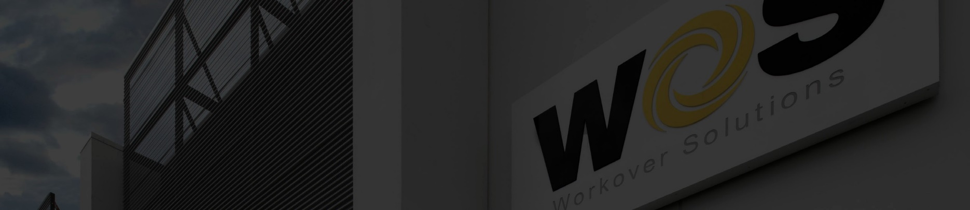

Case Study: WOS Completes Stickpipe Drillout in 10 Days—Over 50%

in Faster Than Competitor in the Kingdom of Saudi Arabia
West Texas 2025

July 2025

In a direct performance comparison under identical operational conditions, WOS executed a stickpipe drillout in just 10 days, outperforming a competing service provider that required 22 days to complete the same task. The operation took place in the Kingdom of Saudi Arabia using a Hydraulic Workover Unit (Snubbing) on a high-pressure, sour gas well containing H₂S and CO₂. This was achieved on only our second KSA well stickpipe drillout operation - highlighting the superior performance of our personnel and tools

Operational Conditions
- Location: Kingdom of Saudi Arabia
- Well Type: Horizontal multistage completion
- Depths & Trajectory: Comparable in both wells
- Hole Conditions: Identical formations, pressure, and sour gas presence
- Rig Equipment & Crew: Same unit, same crew, same shift rotations
- Drillout Type: Stickpipe frac plug drillout using snubbing operations

WOS delivered a zero-NPT (Non-Productive Time) drillout operation by
leveraging advanced tooling, proprietary engineering, and experienced
personnel.

Key differentiators included:
1. In-House Manufactured BHA with Inconel Construction
WOS provided a complete Bottom Hole Assembly (BHA) engineered and fabricated in-house using Inconel, a high-strength, corrosion-resistant alloy ideal for H₂S and CO₂ environments. This ensured mechanical integrity and chemical resilience throughout the operation.

2. 7-11 PioneeR™ PDC Bit Performance
The 7-11 PioneeR PDC bit, specifically designed for high-efficiency frac plug millouts, delivered exceptional performance in sour service. Its cutter layout and optimized hydraulic design ensured stable torque, reduced vibration, and high ROP, eliminating the need for trips due to bit damage or poor progress.

3. Experienced Personnel
WOS deployed highly experienced field engineers with a track record in complex well intervention and drillout operations on a snubbing unit. Their operational discipline and proactive coordination were pivotal in sustaining continuous operations with zero downtime attributable to tools, personnel, or planning.

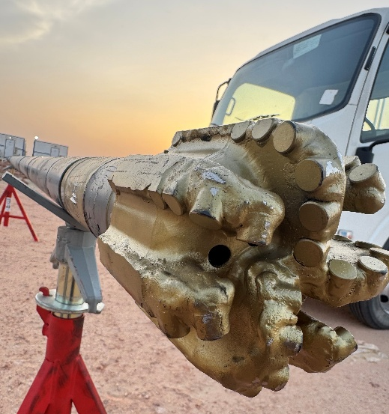

Conclusion
WOS’s performance in this sour gas stickpipe drillout exemplifies how advanced metallurgy, proprietary tooling, and experienced personnel combine to deliver safe, efficient, and cost-effective operations. Under the same rig, crew, and formation conditions, on only our second well WOS achieved a >50% reduction in operational time, proving its capability to execute critical drillouts in harsh well environments—without compromise.
Rev A, 8/2025

