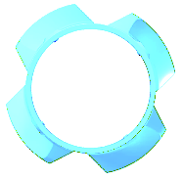
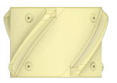
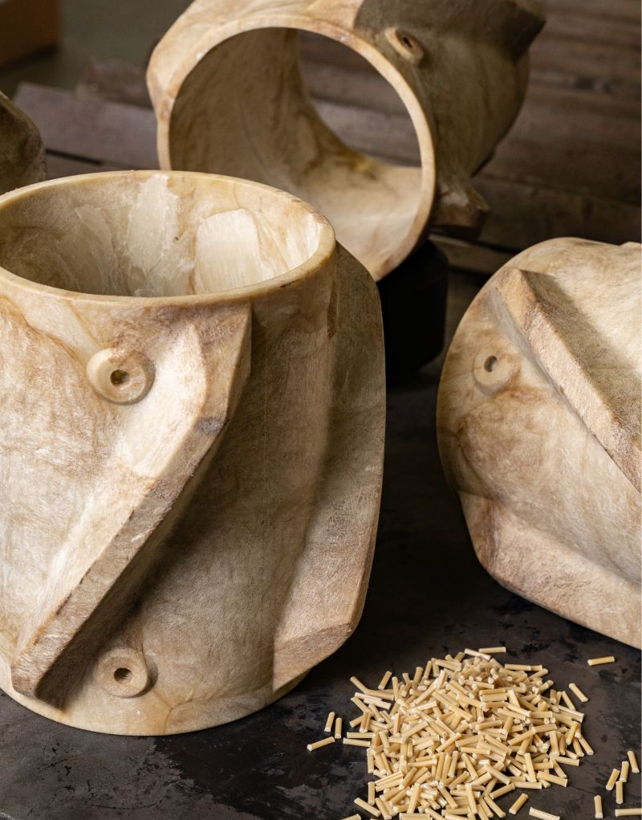




August 2023
Product Details

Size, in 9-5/8
Type Standard
Material Composite
Casing OD, in 9-5/8
Min Hole ID, in 12-1/8
Centralizer ID, in 9-7/8
Centralizer OD, in 12
Length, in 8
Weight, lbs 5.7
Set Screw Inserts No
A Pennsylvania oil and gas operator recently chose Workover Solutions to provide casing components for their casing running operations. The WOS casing CentralizR has an injection-molded, thermoplastic design that reduces costs and time over traditional steel centralizers in this application. On a recent pad, the operator utilized WOS’s CentralizR design for a trial. They gained a significant cost and time savings, simpler make-up operations, and simpler handling due to the compact design of the WOS CentralizR. Since the trial, the operator agreed to continue using the WOS CentralizR on future casing running operations
WOS Casing CentralizRTM
CentralizRTM Achieves Significant Cost Savings and Efficiency Gains for a Pennsylvania Operator
Experienced People, Exceptional Tools
www.workoversolutions.com

sales@workoversolutions.com
- Highly Durable injection-molded thermoplastic material
- Dynamic Blade Design
- Ease of Use in handling and installation
- Low Coefficient of Friction
Casing Centralizer Solutions

- High Costs for Traditional Steel Centralizers
- High Weights Due to Coefficients of Friction on Deeper Wells
- Limited Rig Floor Space

Application Challenges

